WEBD 1000 CSS BACKGROUNDS, BORDERS, SHADOWS, & GRADIENTS

**Website Development**

# Instructions

**You will complete the following steps in class and post the file(s) that you are asked to produce to the Brightspace dropbox for today’s in-class activity. If you need help with any step, ask the instructor.**

1. In the BrightSpace dropbox for today’s activity, you have been provided with with a ZIP file containing some file resources for a web page:
   1. An HTML page called *index.html*
   2. An image called *schoolbussafety.png*
2. Copy the site to an Exercise 11 folder in your preferred folder location for this class.
3. Open the site’s *index.html* file in NotePad++ (or the editor of your choice):
   1. Preview the *index.html* file in a browser. Your page should look like the BEFORE image on the following page.
   2. Add two CSS page to the website called *bus_styles.css* and bus_layout.css and properly link both into the HTML page.
   3. You will make the following additions to the new CSS pages.:
      1. Set the charset of the CSS files to “UTF-8” appropriately.
      2. Add comments marking yourself as the author and with today’s date (in both CSS files)
4. NOTE: WHICH PAGE SHOULD YOU USE? USE THE LAYOUT PAGE FOR LAYOUT (E.G. WIDTHS, POSITIONING) AND THE STYLES PAGE FOR BASIC ELEMENT STYLING (E.G. FONT SIZE, COLORS).
5. Now try to apply CSS rules in the two CSS files to make the site look like the AFTER image on the following page. Make sure to do all of the following:
   * 1. **Apply an appropriate tiled background image to the whole web page.**
     2. **Center the body within the web page with an appropriate width.**
     3. **Give the body a linear gradient background.**
     4. **Make the body border visible.**
     5. **Make the body have rounded corners.**
     6. **Give the body a box shadow.**
     7. **Make the main heading bigger and give it a text shadow.**
6. **REMINDER: See the AFTER example on the next page for an idea of what the Webpage should now look like.**
7. Once the above Steps are completed, validate both your CSS files using the W3C CSS validation website. Take a screenshot showing each successful validation.
8. Post a ZIP file containing the whole website folder plus **screenshots of successful validation** from Step 2 to the Brightspace Dropbox for the eleventh in-class exercise in order to obtain credit for completing it.
9. That’s it.

# Highly Recommended

**There is no need to submit the results of this part of the activity and it will not be graded. However, it will be excellent practice for the upcoming assignment. If you need help with any step, ask the instructor.**

1. Complete the Tutorial 4 – Session 2 practice steps from the Textbook. The practice tutorial steps are in light brown or beige boxes within the chapters of the textbook. In this case the tutorial steps begin on page **HTML305** (Section 4-7a) and conclude on page **HTML323** (Section 4-9) for this Session. **This tutorial continues on from work in the previous Session (4.1), so you may need to go back and complete that if you have not already done so.**
2. Once the above Step is completed, validate the following files using the W3C CSS validation website:
   1. *tb_visual1.css*

# Before:

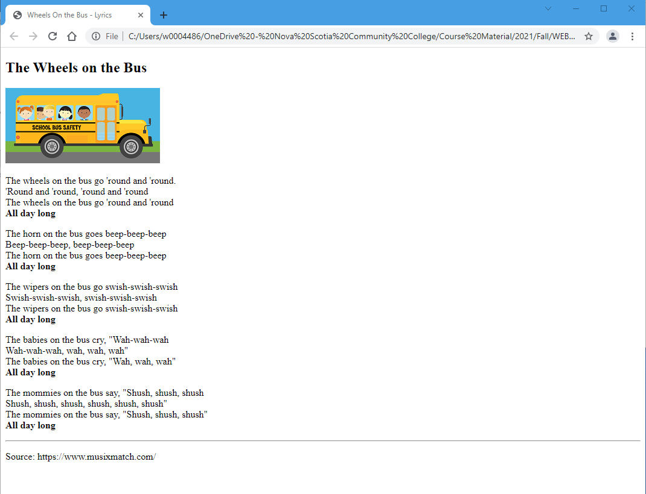

# After:

